Ponrajan Petchimuthu
Oracle to Meridian Graph Database Synchronization Design

1. Overview
This document describes the proposed approach for synchronising data from an Oracle relational database to the Meridian Graph Database.
The solution consists of two phases:
- Initial Full Load
  - Extract all relevant Oracle data.
  - Transform relational entities into graph nodes and relationships.
  - Load data into Meridian Graph Database.
- Incremental (Delta) Synchronisation
  - Oracle triggers capture INSERT, UPDATE, and DELETE events.
  - Changes are recorded in a central CHANGE_LOG table.
  - Meridian Sync Service processes change records and updates the Graph Database.
  - Processed change log records are retained for a defined period and then automatically purged using partition management.

Delta Synchronisation Sequence Diagram
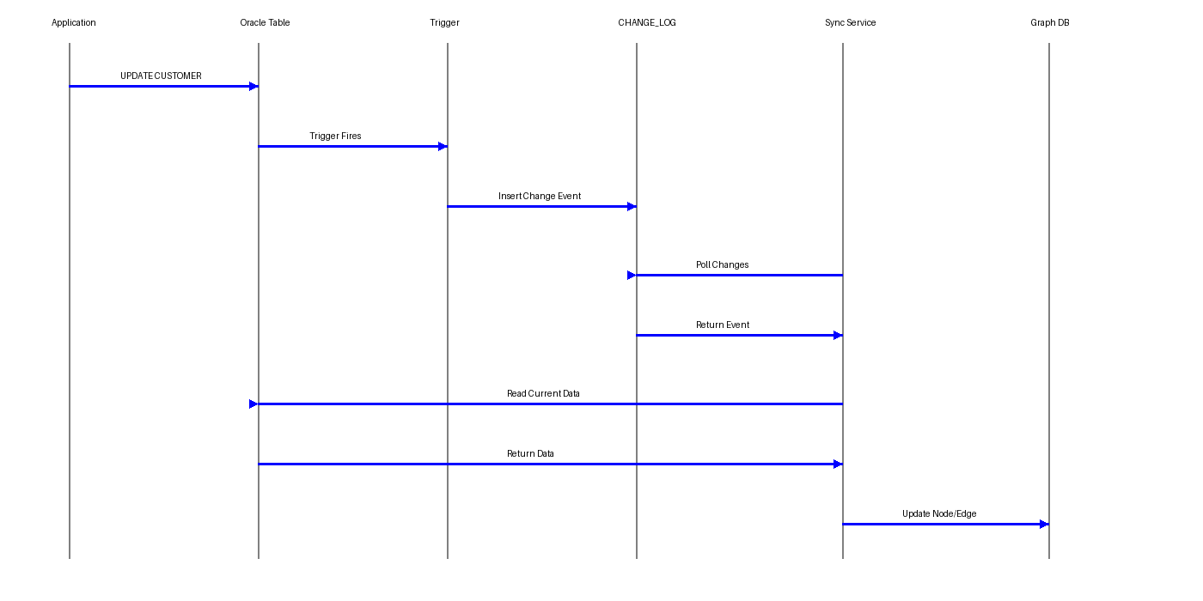
Flow: Application updates Oracle data → Trigger writes to CHANGE_LOG → Meridian Sync Service polls pending changes → Retrieves current data → Updates Graph Database → Marks change as processed.

3. Synchronisation Process
3.1 Initial Full Load
The initial load is a one-time activity.
Activities:
- Extract all source records.
- Create graph vertices (nodes).
- Create graph relationships (edges).
- Validate record counts.
- Capture initial synchronisation checkpoint.

3.2 Delta Synchronisation
After the initial load, only changed records are synchronised.
Supported operations:
- INSERT
- UPDATE
- DELETE
Whenever a source record changes, a trigger writes an entry to the CHANGE_LOG table.

4. Central Change Log Design
A single centralised CHANGE_LOG table is recommended.
Benefits:
- Simpler architecture
- Single processing queue
- Easier monitoring
- Easier retention management
- Easier recovery and replay

Table Structure
CREATE TABLE CHANGE_LOG
(
CHANGE_ID NUMBER PRIMARY KEY,
TABLE_NAME VARCHAR2(100),
ENTITY_TYPE VARCHAR2(100),
RECORD_KEY VARCHAR2(200),
OPERATION_TYPE VARCHAR2(10),
CHANGE_TS TIMESTAMP,
PROCESSED_FLAG CHAR(1),
PROCESSED_TS TIMESTAMP,
RETRY_COUNT NUMBER,
ERROR_MESSAGE VARCHAR2(1000)
);

5. Trigger Design
A trigger is created on each source table.
Example:
CUSTOMER Trigger
CREATE OR REPLACE TRIGGER TRG_CUSTOMER_CHANGE
AFTER INSERT OR UPDATE OR DELETE
ON CUSTOMER
FOR EACH ROW
BEGIN
IF INSERTING THEN
NSERT INTO CHANGE_LOG
(
CHANGE_ID,
TABLE_NAME,
ENTITY_TYPE,
RECORD_KEY,
OPERATION_TYPE,
CHANGE_TS,
PROCESSED_FLAG
)
VALUES
(
CHANGE_LOG_SEQ.NEXTVAL,
'CUSTOMER',
'Customer',
:NEW.CUSTOMER_ID,
'INSERT',
SYSTIMESTAMP,
'N'
);
END IF;
END;

6. Meridian Sync Service
The Meridian Sync Service periodically reads unprocessed records.
Example query:
SQL
1
SELECT *
2
FROM CHANGE_LOG
3
WHERE PROCESSED_FLAG = 'N'
4
ORDER BY CHANGE_ID;
Show more lines
Processing steps:
Plain Text
1
Read Change Log Entry
2
↓
3
Retrieve Current Data
4
↓
5
Transform To Graph Model
6
↓
7
Update Meridian Graph
8
↓
9
Mark Processed
Show more lines
Update statement:
SQL
1
UPDATE CHANGE_LOG
2
SET
3
PROCESSED_FLAG = 'Y',
4
PROCESSED_TS = SYSTIMESTAMP
5
WHERE CHANGE_ID = :CHANGE_ID;
Show more lines

7. Partitioning Strategy
Objective
As the system grows, the CHANGE_LOG table can accumulate millions of records.
Partitioning provides:
- Faster query performance
- Faster cleanup
- Easier retention management
- Reduced maintenance overhead

Recommended Approach
Monthly Interval Partitioning
SQL
1
CREATE TABLE CHANGE_LOG
2
(
3
CHANGE_ID NUMBER,
4
TABLE_NAME VARCHAR2(100),
5
ENTITY_TYPE VARCHAR2(100),
6
RECORD_KEY VARCHAR2(200),
7
OPERATION_TYPE VARCHAR2(10),
8
CHANGE_TS DATE,
9
PROCESSED_FLAG CHAR(1),
10
PROCESSED_TS DATE,
11
RETRY_COUNT NUMBER
12
)
13
PARTITION BY RANGE (CHANGE_TS)
14
INTERVAL (NUMTOYMINTERVAL(1,'MONTH'))
15
(
16
PARTITION P_INITIAL
17
VALUES LESS THAN (DATE '2026-01-01')
18
);
Show more lines
Oracle automatically creates monthly partitions.
Example:
Plain Text
1
P_202601
2
P_202602
3
P_202603
4
P_202604
Show more lines
No manual partition creation required.

8. Indexing Strategy
Create local indexes.
SQL
1
CREATE INDEX IDX_CHANGELOG_PROCESS
2
ON CHANGE_LOG(PROCESSED_FLAG, CHANGE_TS)
3
LOCAL;
Show more lines
SQL
1
CREATE INDEX IDX_CHANGELOG_RECORD
2
ON CHANGE_LOG(RECORD_KEY)
3
LOCAL;
Show more lines
Benefits:
- Faster retrieval of pending records.
- Faster partition maintenance.

9. Retention and Cleanup Strategy
Retention Period
Recommended retention:
Record Type | Retention
Unprocessed | Never purge
Processed | 90 Days
Archived | Optional

Why Keep 90 Days?
Benefits:
- Recovery from synchronisation failures.
- Replay capability.
- Production troubleshooting.
- Graph data reconciliation.
- Operational audits.

10. Partition-Based Cleanup
Avoid deleting rows individually.
Avoid:
SQL
1
DELETE FROM CHANGE_LOG
2
WHERE CHANGE_TS < ADD_MONTHS(SYSDATE,-3);
Show more lines
Reason:
- Generates high redo.
- Consumes resources.
- Longer execution times.

Recommended Cleanup
Drop old partitions.
Example:
Current date:
Plain Text
1
October 2026
Show more lines
Existing partitions:
Plain Text
1
P202607
2
P202608
3
P202609
4
P202610
Show more lines
Drop July partition:
SQL
1
ALTER TABLE CHANGE_LOG
2
DROP PARTITION P202607;
Show more lines
Benefits:
- Executes quickly.
- Minimal impact.
- No large delete operations.

11. Error Handling
Add retry capability.
Plain Text
1
Graph Update Failed
2
↓
3
Increment RETRY_COUNT
4
↓
5
Keep Record Unprocessed
6
↓
7
Retry Later
Show more lines
Example:
SQL
1
UPDATE CHANGE_LOG
2
SET RETRY_COUNT = RETRY_COUNT + 1
3
WHERE CHANGE_ID = :CHANGE_ID;
Show more lines
After maximum retries:
Plain Text
1
Move To Error Queue
2
Raise Alert
3
Manual Investigation
Show more lines

12. Recovery Strategy
If Meridian Sync Service is unavailable:
Plain Text
1
Oracle
2
↓
3
Triggers Continue Logging
4
↓
5
CHANGE_LOG Accumulates Records
6
↓
7
Service Restarts
8
↓
9
Processes Pending Entries
10
↓
11
Graph Becomes Consistent
Show more lines
No data changes are lost.

13. Recommended Solution Summary
For Meridian, the recommended design is:
Plain Text
1
Initial Load
2
------------
3
Oracle → Full Extraction → Meridian Graph
4

5
Delta Load
6
-----------
7
Oracle Tables
8
↓
9
Database Triggers
10
↓
11
Single Partitioned CHANGE_LOG
12
↓
13
Meridian Sync Service
14
↓
15
Meridian Graph Database
16

17
Retention
18
-----------
19
Processed Records : 90 Days
20
Unprocessed Records : Retain Until Processed
21

22
Partitioning
23
-------------
24
Monthly Interval Partitioning
25

26
Cleanup
27
---------
28
Drop Old Partitions Monthly
Show more lines
This approach provides a simple, reliable, and highly maintainable solution for synchronising Oracle data to the Meridian Graph Database without requiring Oracle GoldenGate or other CDC products.
Provide your feedback on BizChat

